APPENDIX 2

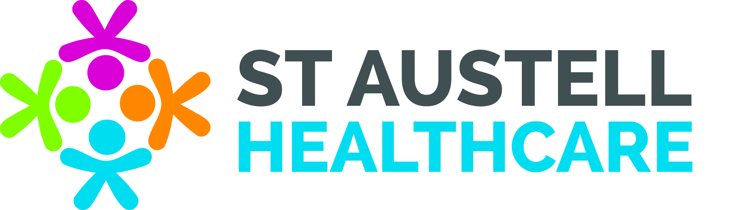

PROXY SystmOne Online access for children aged 11 years until their 16th birthday

Patient’s Full Name: ……………………………………………………………………………..

Patient’s Date of Birth: …………………………………………………………………………..

Patient’s Address: ……………………………………………………………………………….

Information regarding access to online services:
You have decided to grant a family member or carer access to your SystmOne Online account. The person you are granting access to will be able to do the following things on your medical record:

The service you are granting access to is: Request medication

Details of the Parent/Guardian requesting PROXY access:

Full Name: ………………………………………………………………………………..

Date of Birth: ……………………………………………………………………………..

Address: ………………………………………………………………………………….

Relationship: …………………………………………………………………………….

Stopping access:
Proxy access to your online account will be stopped on the day of your 16th birthday.

Even though you have granted access today, you can STOP the access at any time by letting us know in writing (info.sahc@nhs.net) that you no longer want this person to have access to your record.

Please sign below to confirm that you have read and understood the information on this form.

Signature:………………………………………………… Date: …………………………….

To be completed by SAH staff member:-

Name/s of Patients ID Documentation ___________________________________________

Date seen _____/_____/_____

Staff Members Initials __________

