OPTION 2: ELECTRONIC RECORDS
If you were born before the year 2000, part of your medical record is likely to be on paper (“Lloyd George” notes). Prior to computerisation, practices recorded consultations on paper notes. Now notes are electronic, and anything significant from your old paper notes has been summarised and added to your electronic record. If you wish to have a copy of your notes, you can ask for just your electronic notes.

Advantages:
- This information can be sent to you, the patient, by an encrypted email
- You are able to specify the records required are for a specific health issue or for a specified time period.
Disadvantages:
- This is not a full copy of your records (unless you were born after the year 2000) prior to that date the record is a summary only.

To request electronic records, proof of ID & address will be requested during the process.

OPTION 3: Full copy of RECORDS
You can request a full copy of your records, both electronic and paper.
Advantages:
- This is the complete version of your medical notes unless you specify the records required are just for a specific health issue or for a specified time period.
Disadvantages:
- These records must be collected from the practice in person by the patient or their authorised representative in person.
- Resource-heavy and costly for the Practice to produce.

While we appreciate there are occasions when you would need a copy of your full notes, we would ask that this option is only used where it is genuinely needed over and above the other two options—please help us to help you!

To request a full copy of your records, proof of ID & address will be requested during the process.

1 Wheal Northey
St Austell
Cornwall
PL25 3EF

01726 75555
secretaries.sahc@nhs.net
www.staustellhealthcare.co.uk

SUBJECT ACCESS REQUEST (SAR)

General Data Protection Regulations (GDPR) May 2018 &
Access to Health Records Act 1990

This leaflet has been produced to help you in accessing your medical records in respect of a Subject Access Request.

After reading this leaflet, if you require access to your health records, please contact the secretaries on secretaries.sahc@nhs.net detailing which is your preferred method to receive your request.
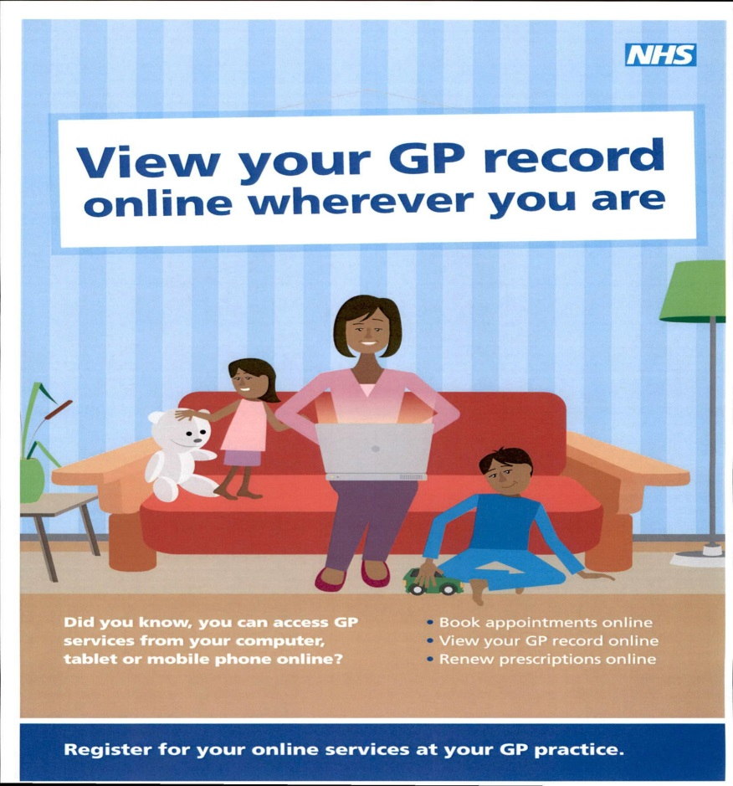

SUBJECT ACCESS REQUESTS (SARs)
Under the General Data Protection Regulations (GDPR), patients have a right to access their medical records without charge – this is called a SUBJECT ACCESS REQUEST.
There are 3 options to get access to your medical record and this leaflet details the various advantages and disadvantages.
For Options 2 & 3 St Austell Healthcare (SAH) will respond within 10 days of receipt of request to obtain clarification of data required and proof of ID and address. SAH will then provide the data requested within 28 days of the initial request.
OPTION 1: ONLINE ACCESS

If you have internet access, you can apply for online access to your medical records. All you need to do is visit one of our Receptions and speak to the Receptionist. You will need to bring a form of photographic ID (i.e. passport, driving licence etc.).

Advantages:
- Available immediately once request and proof of ID has been seen.
- You have “live” access to your records—each time you have a new medication prescribed, a new allergy added, or a new blood test result etc, your copy of the medical records is updated with the information.
- You can view your health records wherever you are, for example, if you are seeing a consultant who has a query about one of your medications you can look it up on your phone.
- If you need a new copy of your notes for another reason, you don’t have to wait a month to get it.
- Online access to your records has other advantages, i.e. booking appointments, requesting repeat medication, but the main one being it allows you to take better control of your health record.

Disadvantages:
- Internet access needed
- Electronic copy of notes
- Record is a summary of notes prior to 2000 as access is to electronic record only

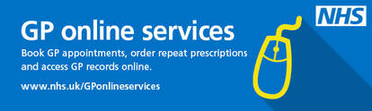

More information on access to online services is available on our website: www.staustellhealthcare.co.uk

